# A1.Analysis

# Team: Pan

Project Manager: Chowdhary, Vanshaj

Release Manager: Johnson, Jessie Greg

Quality Assurance:Vu, Tuan Quang

Design Technical Lead: Yevchak, Steven C

Scribe: Huynh, Trung-Nghia Ngo

**Use Cases**

|  |  |
| --- | --- |
| Use Case Name: | Play Game |
| Entry Condition: | Not currently in a game and in main menu. |
| Exit Condition: | Sixes Wild switches to start game menu. |
| Flow of Events: | 1. Player requests to play a new game. 2. Sixes Wild switches to start game menu. |

|  |  |
| --- | --- |
| Use Case Name: | View Scoreboard |
| Entry Condition: | Not currently in a game and in main menu. |
| Exit Condition: | Sixes Wild displays score and stars for each level. |
| Flow of Events: | 1. Player requests to view scoreboard for a mode. 2. Sixes Wild displays score and stars for each level in the mode. |

|  |  |
| --- | --- |
| Use Case Name: | Back to Main Menu |
| Entry Condition: | Player is in start game menu. |
| Exit Condition: | Sixes Wild displays main menu. |
| Flow of Events: | 1. Player requests to go back to main menu. 2. Sixes Wild displays the main menu. |

|  |  |
| --- | --- |
| Use Case Name: | Select Mode |
| Entry Condition: | Inside Start Game with mode not selected. |
| Exit Condition: | Game mode is selected. |
| Flow of Events: | 1. Player requests a game mode. 2. Sixes Wild selects game mode. |

|  |  |
| --- | --- |
| Use case | Select level |
| Entry Condition | - Menu access  - Not currently playing a game |
| Exit Criteria | A game level is selected |
| Flow of Event | 1. Player requests to select a game level  2. Sixes Wild sets game level |

|  |  |
| --- | --- |
| Use Case Name: | Select Name |
| Entry Condition: | Player is in start game menu. |
| Exit Condition: | Sixes Wild selects the name. |
| Flow of Events: | 1. Player requests to select name. 2. Sixes Wild selects the name. |

|  |  |
| --- | --- |
| Use case | Start game |
| Entry Condition | - Menu access  - Not currently playing a game  - A game mode is selected  - A game level is selected |
| Exit Criteria | A new game starts |
| Flow of Event | 1. Player requests to start game  2. Sixes Wild starts a game |

|  |  |
| --- | --- |
| Use case | See current game mode and level |
| Entry Condition | Currently playing a game |
| Exit Criteria | Game mode and level is shown |
| Flow of Event | - Player requests to see current game mode and level  - Sixes Wild shows current game mode and level |

|  |  |
| --- | --- |
| Use case | See current game statistics |
| Entry Condition | Currently playing a game |
| Exit Criteria | Current game statistics are shown |
| Flow of Event | - Player requests to see current game statistics  - Sixes Wild shows current game statistics |

|  |  |
| --- | --- |
| Use case | Quit Game |
| Entry Condition | Player is currently playing a game. |
| Exit Criteria | Sixes Wild switches to the main menu screen. |
| Flow of Event | 1. Player requests to quit the game. 2. Sixes wild quits the game, and switches to the main menu screen. |

|  |  |
| --- | --- |
| Use Case Name: | Win Game |
| Entry Condition: | Player is currently playing a game. |
| Exit Condition: | Sixes Wild switches to the post-game menu and unlocks the next level. |
| Flow of Events: | 1. Player satisfies the winning conditions of the game. 2. Sixes Wild switches to the post-game menu and unlocks the next level. |

|  |  |
| --- | --- |
| Use Case Name: | Lose Game |
| Entry Condition: | Player is currently playing a game. |
| Exit Condition: | Sixes Wild switches to the post-game menu. |
| Flow of Events: | 1. Player runs out of time/moves and has not reached winning condition. 2. Sixes wild switches to the post-game menu. |

|  |  |
| --- | --- |
| Use Case Name: | Remove tiles |
| Entry Condition: | Player is currently playing a game and the selected tiles add up to 6. |
| Exit Condition: | Sixes Wild removes the selected tiles, updates score, and updates the board. |
| Flow of Events: | 1. Player requests to remove tiles. 2. Sixes Wild removes the tiles, updates score, and updates the board. |

|  |  |
| --- | --- |
| Use Case Name: | Select group of tiles |
| Entry Condition: | Player is currently playing a game |
| Exit Condition: | Sixes wild selects the group of tiles. |
| Flow of Events: | 1. Player requests to select a group of tiles. 2. Sixes Wild selects the tiles. |

|  |  |
| --- | --- |
| Use Case Name: | Update Score |
| Entry Condition: | A valid move has been made by the player. |
| Exit Condition: | Sixes Wild updates the score |
| Flow of Events: | 1. Player makes a move. 2. Sixes Wild updates the score based on the move. |

11-15

|  |  |
| --- | --- |
| Use Case | Use power-up swap |
| Participating Actor | Player |
| Entry Condition | There are at least two tiles on the board |
| Exit Criteria | The contents of two selected tiles are swapped |
| Flow of Events | 1. Player requests to swap two tiles. 2. Board is updated to reflect tiles swap. |

|  |  |
| --- | --- |
| Use Case | Use power-up remove |
| Participating Actor | Player |
| Entry Condition | There is at least one tile on the board |
| Exit Criteria | The content of the selected tile *a* is removed; the tiles above *a* in the same column shift downward one tile; one new tile is created at top |
| Flow of Events | 1. Player requests to remove one tile. 2. Board is updated to reflect removed tile. |

|  |  |
| --- | --- |
| Use Case | Use power-up reset |
| Participating Actor | Player |
| Entry Condition | Tiles remain on the board |
| Exit Criteria | The contents of all the tiles on the board are randomly swapped |
| Flow of Events | 1. Player requests to reset the board. 2. Board is updated to reflect board reset. |

|  |  |
| --- | --- |
| Use Case Name: | Restart level |
| Entry Condition: | Player has finished the level and is in the post-game menu. |
| Exit Condition: | Sixes Wild starts the same level again. |
| Flow of Events: | 1. Player requests to restart level. 2. Sixes Wild restarts level. |

|  |  |
| --- | --- |
| Use Case Name: | Back to Main Menu |
| Entry Condition: | Player has finished the level and is in post-game menu. |
| Exit Condition: | Sixes Wild switches to main menu screen. |
| Flow of Events: | 1. Player requests to main menu. 2. Sixes Wild switches to main menu. |

|  |  |
| --- | --- |
| Use Case Name: | Go To Next Level |
| Entry Condition: | Player finished a level and requests to go to the next level |
| Exit Condition: | Sixes’ Wild starts the next level. |
| Flow of Events: | 1. Player requests to go to the next level. 2. Sixes’ Wild starts the next level in the mode. |

|  |  |
| --- | --- |
| Use Case Name: | Go To Main Menu |
| Entry Condition: | Player finished a level and requests to go to main menu. |
| Exit Condition: | Sixes’ Wild switches to the main menu screen. |
| Flow of Events: | 1. Player requests to go to the main menu. 2. Sixes’ Wild opens the main menu screen. |

|  |  |
| --- | --- |
| Use Case Name: | Update high score |
| Entry Condition: | Player finished a level and has gotten a higher score than previous high score. |
| Exit Condition: | Sixes Wild updates the high score for the level. |
| Flow of Events: | 1. Player finishes a level. 2. Sixes wild updates the high score. |

--- Level Builder ---

|  |  |
| --- | --- |
| Use Case Name: | Create a level |
| Entry Condition: | None. |
| Exit Condition: | Level Builder creates a level. |
| Flow of Events: | 1. Creator requests to create a level. 2. Level Builder creates the level. |

|  |  |
| --- | --- |
| Use Case Name: | Set level and mode |
| Entry Condition: | Level Builder has been started. |
| Exit Condition: | The Mode and the Level have been selected. |
| Flow of Events: | 1. Creator requests to create a level with a specific mode and level number. 2. Level Builder selects the level and mode. |

|  |  |
| --- | --- |
| Use Case Name: | Set winning conditions |
| Entry Condition: | Creator has selected the mode and the level and requests to set the winning conditions |
| Exit Condition: | Level Builder sets the winning conditions. |
| Flow of Events: | 1. Creator requests to set the level with the moves/time remaining, and required score. 2. Level Builder sets the level with the moves/time remaining, and required score. |

|  |  |
| --- | --- |
| Use Case Name: | Set Powerups |
| Entry Condition: | None. |
| Exit Condition: | Level Builder sets the number of powerups for the level. |
| Flow of Events: | 1. Creator requests for a number of powerups to be allowed in the level. 2. Level Builder sets the number of powerups for the level. |

|  |  |
| --- | --- |
| Use Case Name: | Set Starting Board |
| Entry Condition: | Creator has selected the mode. |
| Exit Condition: | Level Builder sets the starting board. |
| Flow of Events: | 1. Creator requests to set the starting board. 2. Level Builder sets the starting board. |

|  |  |
| --- | --- |
| Use Case Name: | Set star requirements |
| Entry Condition: | None. |
| Exit Condition: | Level Builder sets the score required for achieving getting stars. |
| Flow of Events: | 1. Creator request to set star requirements. 2. Level Builder sets the star requirements. |

|  |  |
| --- | --- |
| Use Case Name: | Set probability of each value |
| Entry Condition: | None |
| Exit Condition: | Level Builder sets the probability for values 1 through 6. |
| Flow of Events: | 1. Creator requests to set the probability for each value appearing. 2. Level Builder sets the probability for each value appearing. |

|  |  |
| --- | --- |
| Use Case Name: | Set probability of multiplier |
| Entry Condition: | None. |
| Exit Condition: | Level Builder sets the probability of getting x1, x2, and x3 multipliers. |
| Flow of Events: | 1. Creator requests to set the probability of the multipliers 2. Level Builder sets the probability of the multipliers. |

|  |  |
| --- | --- |
| Use Case Name: | Randomize Level |
| Entry Condition: | None. |
| Exit Condition: | Level Builder randomly sets the mode, winning conditions, starting board, score requirements for stars, and the probability for tiles and multipliers. |
| Flow of Events: | 1. Creator requests to randomize level. 2. Level Builder randomly sets the mode, winning conditions, starting board, score requirements for stars, and the probability for tiles and multipliers. |

|  |  |
| --- | --- |
| Use Case Name: | Load level |
| Entry Condition: | None. |
| Exit Condition: | Level Builder loads the level. |
| Flow of Events: | 1. Creator requests to load a level. 2. Level Builder loads the level. |

|  |  |
| --- | --- |
| Use Case Name: | Save level |
| Entry Condition: | Creator has created a level. |
| Exit Condition: | Level Buildersaves the level. |
| Flow of Events: | 1. Creator requests to save the level. 2. Level Builder saves the level. |

**Mockup GUI**

Splash Screen



Main Menu



Scoreboard Menu



Credits Menu



Pre-game Menu



In-game Menu



Post-game Menu



Level Builder



Use Case Diagrams

Entity In-game Diagram

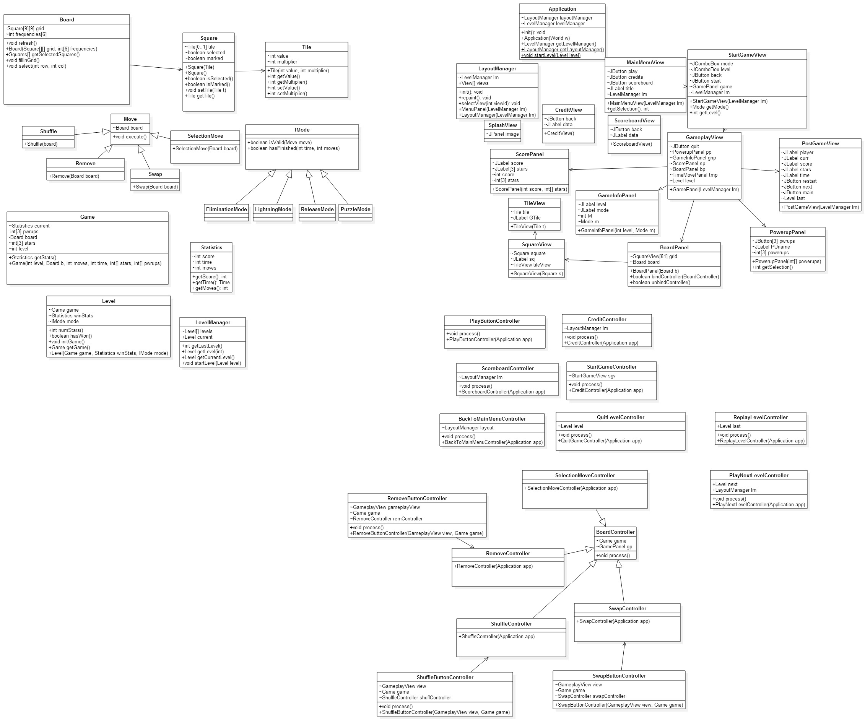

Boundary In-game Diagram



Controller In-game Diagram



**Entity Diagram for Level Builder**

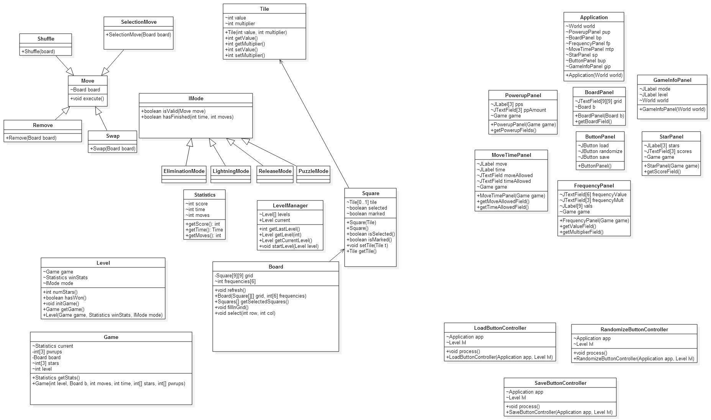

**Boundary Diagram for Level Builder**



**Controller Diagram for Level Builder**

